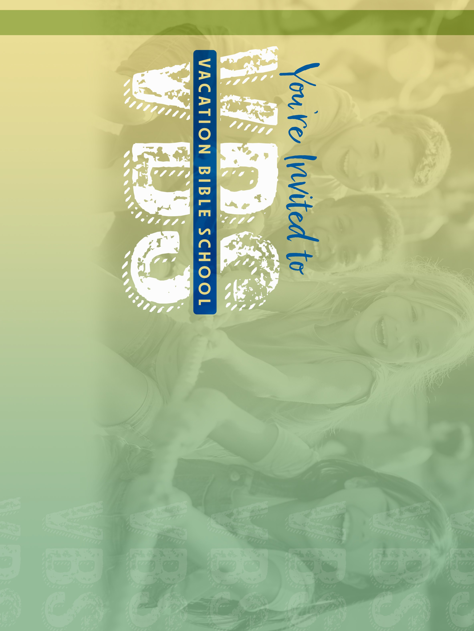
BIBLE STORIES // ARTS & CRAFTS // FELLOWSHIP // MUSIC // SPORTS // SNACKS
@ Church Name
June 0-0 // 0pm-0pm
For Ages 5-12
BIBLE STORIES // ARTS & CRAFTS // FELLOWSHIP // MUSIC // SPORTS // SNACKS
@ Church Name
June 0-0 // 0pm-0pm
For Ages 5-12
BIBLE STORIES // ARTS & CRAFTS // FELLOWSHIP // MUSIC // SPORTS // SNACKS
@ Church Name
June 0-0 // 0pm-0pm
For Ages 5-12
BIBLE STORIES // ARTS & CRAFTS // FELLOWSHIP // MUSIC // SPORTS // SNACKS
@ Church Name
June 0-0 // 0pm-0pm
For Ages 5-12


@ Church Name
000 Street Name // City, ST 00000
@ Church Name
000 Street Name // City, ST 00000
Lorem ipsum dolor sit amet, consec-
tetur adipiscing elit, sed do eiusmod tempor incididunt ut labore et dolore magna aliqua.
Lorem ipsum dolor sit amet, consec-
tetur adipiscing elit, sed do eiusmod tempor incididunt ut labore et dolore magna aliqua.
Sign up today at
the desk in the lobby or at www.churchname.com/vbs
Sign up today at
the desk in the lobby or at www.churchname.com/vbs
@ Church Name
000 Street Name // City, ST 00000
@ Church Name
000 Street Name // City, ST 00000
Lorem ipsum dolor sit amet, consec-
tetur adipiscing elit, sed do eiusmod tempor incididunt ut labore et dolore magna aliqua.
Lorem ipsum dolor sit amet, consec-
tetur adipiscing elit, sed do eiusmod tempor incididunt ut labore et dolore magna aliqua.
Sign up today at
the desk in the lobby or at www.churchname.com/vbs
Sign up today at
the desk in the lobby or at www.churchname.com/vbs

PLACE STAMP HERE

PLACE STAMP HERE

PLACE STAMP HERE

PLACE STAMP HERE

