


Made With Love
© 2022 CRI

Type your message here.




Made With Love
© 2022 CRI

Type your message here.
Made With Love
© 2022 CRI



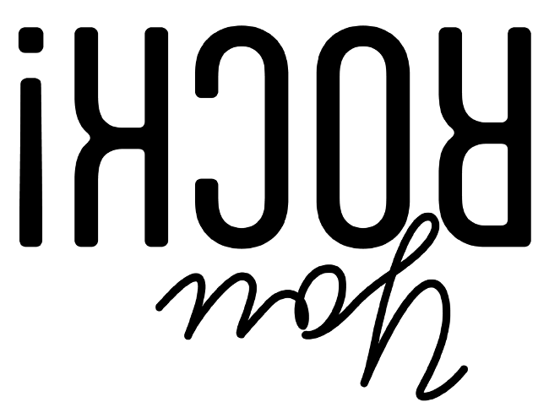

Type your message here.

Made With Love
© 2022 CRI




Type your message here.

Made With Love
© 2022 CRI




Type your message here.




Made With Love
© 2022 CRI

Type your message here.



Thank you for purchasing from Communication Resources, Inc, the parent company of ChurchArt Pro. The content you’ve purchased is part of a ChurchArt Pro subscription. Below includes the copyright policy for the content you’ve purchased.

What Customers Can Do
- Alter images and content for personalized use (such as adding a logo or special message) within their own church or parish.
- Republish and reproduce images and content for use within their own church or parish.
- Print any art and content from ChurchArt Online for use within their own church or parish. See a complete list of media available under Print Use.
- Post several (but not all) types of art and content from ChurchArt Online to their church's website and social medial platforms without permission from ChurchArt Online. See a complete list of images and content available under Online Use.

What Customers Can't Do
- Share images or content with other churches and parishes (even within your denomination) or companies.
- Republish images or content in any form for resale or redistribution, either in its original format or in an edited form.
- Publish cartoons, activity sheets, lessons, teachers' guides, or children's bulletins in any format, including mobile apps, unless protected by a password.

Print Use
Customers may print any of the art or content found within ChurchArt Online for use within the church or parish. This includes but is not limited to printing and reproducing: Bulletin covers, Photos, Illustrations, Personalized Templates, Cartoons, Activity sheets & Puzzles, Story Guides, Lessons, Snacks, Crafts
Customers may print the art or content found within ChurchArt Online in their print advertising or promotional material for public events such as Vacation Bible School, Easter Service, etc. as long as it is not a pay-for event.

Online Use
Customers may post the following to their church's website and social medial platforms without permission from ChurchArt Online: Photos, Illustrations, Clipart, Bulletin Covers, Personalized Templates
Customers may post the following online with this copyright ©ChurchArt Online included: Snacks, Crafts, Maps, Sermon Notes
Customers may not post the following anywhere online in any format (including mobile apps, Google Drive, Dropbox, and other online sharing platforms) unless protected behind a password that is distributed only to your church's members: Cartoons, Activity Sheets & Puzzles, Children's Bulletins, Teacher Guides, Lessons, Original Microsoft Word or Publisher Template Files, Original Microsoft PowerPoint Template Files
This list was last updated 6/14/2022. We reserve the right to change, modify, add or remove portions of this policy at our discretion at any time.

Enforcement
If the Company discovers a reason to believe the Customer has violated this policy, the Company may restrict or cut off the Customer's ability to download or use material from the website. Promptly after restricting access, the Company agrees to send notice to the email address the Customer provided via the website. These abilities do not limit the Company's ability to pursue other means of enforcement, such as taking legal action.
Unsure if the way you wish to use an image or content fits within our policy? Feel free to email us at service@comresources.com and we will gladly review your request.

© CRI | PO Box 9290, Canton, OH 44711 | www.ChurchArt.com

